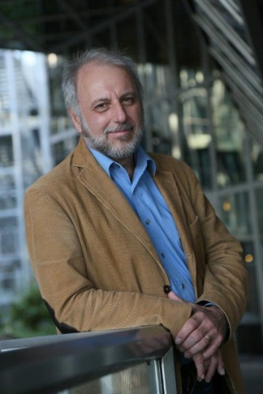
Univ.-Prof. Dr. habil. Peter Baumgartner
Department of Interactive Media and Educational Technology
Danube University Krems (DUK)
Dr. Karl-Dorrek-Strasse 30
A-3500 Krems
Austria

E-mail: peter.baumgartner@donau-uni.ac.at
Personal Homepage: http://www.peter.baumgartner.name
University: www.donau-uni.ac.at/en/universitaet/whois/06393
Department: www.donau-uni.ac.at/en/department/imb

BIOGRAPHY

PETER BAUMGARTNER was born 1953 in Vienna, Austria. He studied sociology at the University of Vienna, where he obtained his doctoral degree in 1980. After working for a couple of years as a freelance scientist and consultant for the Austrian Government and different universities he went as an assistant professor to the University of Klagenfurt. 1992 he wrote his habilitation thesis on “Background Knowledge – Groundwork for a Critique of Computational Reason” and published it (in German).

After several research leaves (1983: Universidad Autónoma de Mexico, 1989: Institute of Cognitive Studies at University of California in Berkeley, 1994: GMD, now Fraunhofer-Gesellschaft St. Augustin in Germany) and different positions as university professor (Muenster/Germany, Innsbruck/Austria, FernUniversitaet in Hagen). Peter Baumgartner is now full professor for Technology enhanced learning and Multimedia at Danube University Krems, the first European university specialised in Continuing Education. He is the head of the Department of Interactive Media and Educational Technology.

Since 1992 Peter Baumgartner has focused his research work on learning theory, eLearning scenarios and blended learning arrangements, distance education, didactics and teacher training, strategies for the organisational implementation of eLearning and evaluation methodology. During this time he has published 12 books and over 190 articles.

Many of these articles are available for download on his webpage at
http://www.peter.baumgartner.name/.

In 2011 Peter Baumgartner published his major-book “Taxonomie von Unterrichts-methoden - Ein Plädoyer für didaktische Vielfalt”, which could be translated as “Taxonomy of Teaching Methods – A Plea for Educational Diversity”. It contains a proposal for an educational taxonomy based on 12 dimensions and presents, based on this theoretical premise, a collection of (blended) learning scenarios as well. His latest book “Schaufenster des Lernens - Eine Sammlung von Mustern zur Arbeit mit E-Portfolios”, translated as “Showcase of Learning – A Collection of Patterns to work with E-Portfolios” has been published in 2012.

Peter Baumgartner was the scientific director of a prestigious award for university teachers, which is endowed every year with 100.000 Euro (Medidaprix http://www.medidaprix.org/). He is board member of the Styria Research Council for “Research, Innovation and Technology for the Future” of the regional government of Styria and of several other advisory councils and committees concerned with eLearning.
His scientific work is also dedicated to pattern and pattern languages (15 properties of Christopher Alexander). He is responsible for the international conference PURPLSOC (Pursuit of Pattern Languages for Societal Change) and with Richard Sickinger he edited the book “PURPLSOC The Workshop 2014”.

